

Preliminary Examinations II 2010

Pre-university 3

H2 CHEMISTRY 9647 / 03

Tuesday 14 Sep 2010 2h

Additional materials:
Writing Paper
Data Booklet

READ THESE INSTRUCTIONS FIRST

- Do not turn over this question paper until you are told to do so.

- Write your name, class and index number in the spaces provided at the top of this page and on all the work you hand in.

- Write in dark blue or black pen on both sides of the paper.

- You may use a soft pencil for any diagrams or graphs.

- DO NOT use staples, paper clips, highlighters, glue or correction fluid or tape.

- Answer FOUR out of five questions.

- Give non-exact numerical answers correct to 3 significant figures, or 1 decimal place in the case of M_{r} and A_{r}, unless a different level of accuracy is specified in the question.

- The number of marks is given in brackets [ ] at the end of each question or part question.

- You are reminded of the need for good English and clear presentation in your answers and to show all working in calculations.

- The use of a calculator is expected, where appropriate.

- (a) (i) Describe and explain the trend observed in the thermal stability of the carbonates of the Group II elements. [3]

(ii) By quoting suitable data from the Data Booklet suggest how the thermal stabilities of
- zinc carbonate and
- lead carbonate
might compare to that of calcium carbonate. [2]

(b) Malachite is an ore of copper. It contains the following percentages by mass.

Cu, 57.7% O, 36.2% C, 5.4% H, 0.9%

Malachite reacts with dilute H₂SO₄ producing a gas B that forms white precipitate with limewater and leaving behind a blue solution C.

When heated in the absence of air, malachite produces gas B and steam, and leaves a black solid D. D reacts with dilute H₂SO₄ to produce the same blue solution C.

Adding iron filings to C produces a pink solid E and a pale green solution F.

- Calculate the empirical formula of malachite. [2]

- Suggest the formula of the ion responsible for the blue colour of solution C. [1]

- Identify the black solid D and calculate the mass of D that could be obtained by heating 10 g of malachite. [2]

- Use data from the Data Booklet to identify the pink solid E and the solution F, and suggest an equation for the reaction producing them. [2]

- Describe and explain, with the aid of equations, what you would see when dilute NH₃(aq) is added slowly to the solution C until it is in an excess. [4]

(c) Ammonia is a base. Arrange the following nitrogen compounds in order of increasing pK_{b}. Explain your answer. [4]

ammonia, ethylamine, 2-chloroethylamine, phenylamine

[Total: 20 marks]

- These are the reaction steps in a certain polymerisation process, which may occur by either an uncatalysed or an acid-catalyzed pathway.

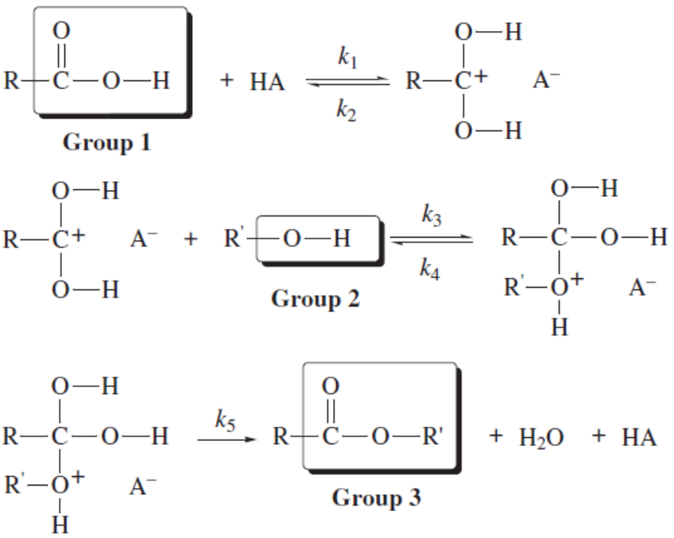

- Write a balanced equation for the overall reaction. [1]

- Redraw Step 1 and 2 of the mechanism to show the movement of electron pairs in the polymerisation process by indicating the curly arrows, dipoles and lone pairs of electrons involved. [3]

- Name the functional groups labeled [1], [2], and [3]. [2]

- Given the following data for the acid-catalyzed reaction, find the rate law and the value of k, specifying its units. [5]

[RCOOH]  / mol dm^{–3} | [R´OH]  / mol dm^{–3} | [HA]  / mol dm^{–3} | Initial Rate  / mol dm^{–3} min^{–1}
0.35 | 0.35 | 0.50 | 4.60
0.62 | 0.35 | 0.50 | 8.14
0.35 | 0.81 | 0.50 | 10.6
0.35 | 0.50 | 0.75 | 9.84

- The initial reaction rate can be followed spectrophotometrically by quenching the reaction and determining the amount of ROH left by its reaction with dichromate ion, Cr₂O₇^{2–}.

- Suggest how quenching can be done for this experiment. [1]

- By using CH₃CH₂OH, write a balanced equation to represent the reaction of Cr₂O₇^{2–} with R´OH in acid solution. [1]

- Describe the color change expected for the reaction written in (eii). [1]

- Polymerisation also occurs in nature, e.g. formation of proteins.

Describe how peptide bonds are formed between amino acids during the formation of a tripeptide. Include diagrams and displayed formulae in your answer. You may use the general formula of amino acid, H₂NCHRCO₂H, in your diagram [3]

- Describe how proteins can be broken down into amino acids in the laboratory without the aid of enzymes. [1]

- Heavy metal ions like Hg²⁺ can bind irreversibly to enzymes and this can result in poisoning.

  - Suggest to what atom or group Hg²⁺ ions bind. [1]

  - Explain how this affects enzyme activity. [1]

[Total: 20 marks]

- Consider the formation of N₂O₅(g) by this reaction.

2NO₂(g) + ½O₂(g) N₂O₅(g)

Type of Data | ΔH_{rxn} | ΔS_{rxn} | ΔH_{f}
Substance |  |  | NO₂(g)
Value | –55.1 kJ | –227 J K^{–1} | +33.2 kJ mol^{–1}

- Using the data provided, draw an energy cycle and hence calculate the ΔH_{f} of N₂O₅(g). [2]

- Draw the dot–and–cross diagrams for NO₂ and N₂O₅. [2]

- Using the bond energies given below, calculate another value for enthalpy change of reaction, ΔH_{rxn} and hence explain why they differ. [3]

Bond | N–O | N=O | N–N | N=N | N≡N | O–O | O=O
Energy  / kJ mol^{–1} | 230 | 631 | 160 | 410 | 994 | 150 | 496

- State and explain

- whether the above reaction is spontaneous at 25 °C. [2]

- how the relative amounts of reactant and product molecules would be affected by an increase in temperature. [2]

- State how the numerical value of K_{p} would be affected by an increase in pressure. [1]

- A is C₈H₉NO₂. On heating under reflux, with excess dilute hydrochloric acid, A yields two compounds B, C₆H₈NClO, and C, C₂H₄O₂.

After complete separation, C was found to react with sodium carbonate, liberating a colourless gas. B is soluble in aqueous sodium hydroxide, and gives a white precipitate with aqueous bromine.

Deduce the full structural formulae of compounds A to C and hence write balanced equations for all the reactions above. [8]

[Total: 20 marks]

- The presence of CO₃^{2–}, HCO₃– and CO₂ in body fluids helps to stabilize the pH of these fluids despite the addition or removal of H⁺ ions by body processes.

Answer the following questions about solutions containing these species in varying
combinations at 25 °C.

H₂CO₃(aq) H⁺(aq) + HCO₃–(aq) K₁ = 4.2 x 10^{–7} mol dm^{–3}
HCO₃–(aq) H⁺(aq) + CO₃^{2–}(aq) K₂ = 4.7 x 10^{–11} mol dm^{–3}

    - Calculate the [H⁺] and pH expected for

- 0.033 mol dm^{–3} solution of H₂CO₃, which is the saturation point of CO₂ at 25 °C. [2]

- 0.125 mol dm^{–3} solution of CO₃^{2–}. [3]

    - The “normal” pH in blood plasma is 7.40. Identify the components that would provide the best buffer at this pH and hence calculate their ratio. [2]

    - Using your answer in (b), write equations to show how the buffer in blood helps to maintain the pH. [2]

    - Sketch a titration curve to show the variation in pH if blood was titrated against sodium hydroxide. [2]
    - A yellow liquid D, C₇H₇NO₂, reacts with alkaline potassium manganate(VII) and on acidification gives a pale yellow solid E, C₇H₅NO₄.

After treating D with tin and hydrochloric acid, the addition of sodium hydroxide releases a dark coloured liquid, F.

Under suitable conditions for reduction (with hydrogen under pressure at 160 °C in the presence of nickel) D is slowly converted into G, C₇H₁₅N. G reacts with excess of iodomethane to give a quaternary salt, H, of formula C₇H₁₃(CH₃)_{x}NI.

  - Deduce the possible structures of D to G, giving your reasons. [4]

  - Describe and explain a chemical reaction in which F and G behave similarly.
[2]

  - Deduce the value of x in H and give its displayed structure. Give a reason that H dissolves in water while the rest of the compounds do not. [3]

[Total: 20 marks]

- Transition metal ions are often brightly coloured and can exist in a wide range of oxidation states.

Vanadium is particularly diverse: an oft-used chemistry demonstration involves swirling a vanadium(V) solution with zinc in a flask, which causes the solution to change colour from yellow to blue to green and finally, pale violet.

Species | Colour | Oxidation State
V(s) |  | 0
V²⁺(aq) | Pale violet | +2
V³⁺(aq) | Green | +3
VO²⁺(aq) | Deep Blue | x
VO₃–(aq) | Yellow | y

- Determine the value of x and y. [1]

- Explain why vanadium is able to exhibit varying oxidation states. [1]

- (i) The vanadous ion (V²⁺) is used in a redox titration to determine the concentration of an unknown solution containing the Fe³⁺ ion. Iron(III) is reduced to iron(II), and the solution is acidic throughout the determination. The colour of the products is green.

Write the balanced equation for the reaction between Fe³⁺ and V²⁺ under the stated condition. [1]

(ii) Fiona, an earnest young analytical chemist, was confused and thought that the final colour of the products should be deep blue. With reference to the Data Booklet, explain how she came to this conclusion and why her reasoning was flawed. [3]

- Fiona, an earnest young analytical chemist, decided to make 250 cm³ of 0.500 mol dm^{–3} vanadous sulfate (VSO₄) solution. She had a bottle of vanadyl sulfate (VOSO₄•2H₂O), which she stirred with an excess of zinc metal (amalgamated with a small amount of mercury(II) catalyst). Since it was getting late, Fiona decided to filter the solution and leave it out on the bench, with the intention to perform the titration the next day. Disaster struck! Fiona returned to find her perfectly prepared pale violet solution had a slight green tinge.

With reference to the Data Booklet, explain the phenomenon observed. [2]

- The indicator used in the titration is potassium thiocyanate, KSCN. The thiocyanate ions, SCN–, form an intense blood red complex ion with Fe³⁺ in solution.

Explain why transition metal compounds are coloured by making specific reference to the example stated above. [3]

- Fiona also discovered the possibility of the following reaction between the vanadous ions and hydrogen ions in solution:

2V²⁺(aq) + 2H⁺(aq) → 2V³⁺(aq) + H₂(g)
Fortunately this reaction is very slow under normal conditions. Fiona remembered that solution–phase reactions usually occur in two steps: the reactants first associate, or come together, and then react to form products.

Step 1: A + B A•B
Step 2: A•B → C

Explain why the reaction might be slow. [1]

- Suggest a test or simple reaction you could carry out on each of the following pairs of compounds to enable them to be distinguished. [4x2]

- CH₃COCH₂CH₂CH₃ CH₃CH₂COCH₂CH₃
J K

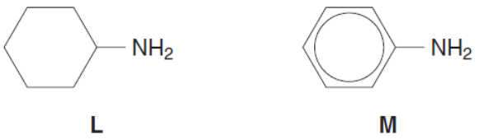

- CH₃CH₂COCl CH₃CH₂CH₂Cl
N P

- CH₃CH₂CONH₂ CH₃CH₂CH₂NH₂
Q R

[Total: 20 marks]

